**TheTOD Idea**

“Re-Inventing Education using Technology**”**

***P.O. Box 6563, Kampala Uganda Kati House, Nakasero Tel: 0757112376.***

# Type of Business:

# Integrating Technology in Education

**Who are we?**

The TOD idea is an indigenous owned company started in September 2013 with the aim of integrating technology in Education and Business.

Our Mission is get all Ugandans students learning, Revising and Researching using the EduTab.

We believe in the ability of technology to make quality education available and scalable in order to have an impact on the African condition.

The EduTab

EduTabs are Tablet Pcs upon which we have installed educational software (Apps) , Videos and e-books customised to suit nursery , primary and secondary school levels.

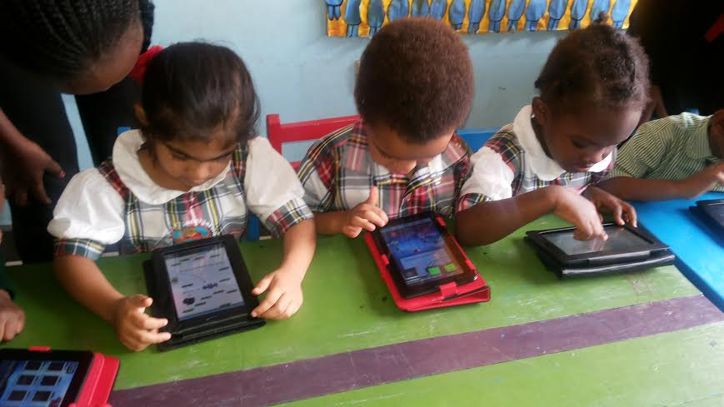

**What do we hope to achieve with the Edutab??**

To impart upon our student force the 21st century skills of communication, collaboration and critical thinking which are ICT based.

We also believe that the EduTabs will increase proficiency and interest in studies by the students and result in higher examination scores

TechKids ICT Clubs:

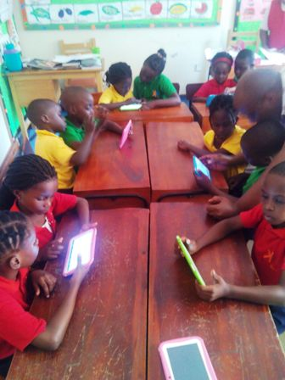

**TechKids** is an after school computer programming club where kids use the EduTab to learn how to program computers.

Computer programming skills are highly sought after by employers so this improves children’s future career prospects.

The critical thinking skills and problem solving skills developed in this club spill over into the children’s academic performance and are important life skills too.

We are currently operating in Kinderkare Elementary School kitante and look to open up in several other schools and run holiday programmes as well.

The company directors

Mbanda Shyaka:



Position: Managing Director:

A graduate of the school of Food Science and Technology Makerere, Mbanda Shyaka has vast experience in the business world which he joined in the year 2000 right after graduating. Areas of business include finance, agriculture and trade.

Nkusi Alex Shyaka:



Position: CTO/Director Operations

A graduate of Applied Information Technology from Sikkim Manipal University India , and attained a diploma in Software engineering from the London School of Computer technology United Kingdom. Mr. Nkusi has worked in software companies in the United states of America and Uganda.

He is currently managing the IT department of Global Health Economics, a multinational consultancy group.